Minimax Algorithm

Python.file:

Screenshot:
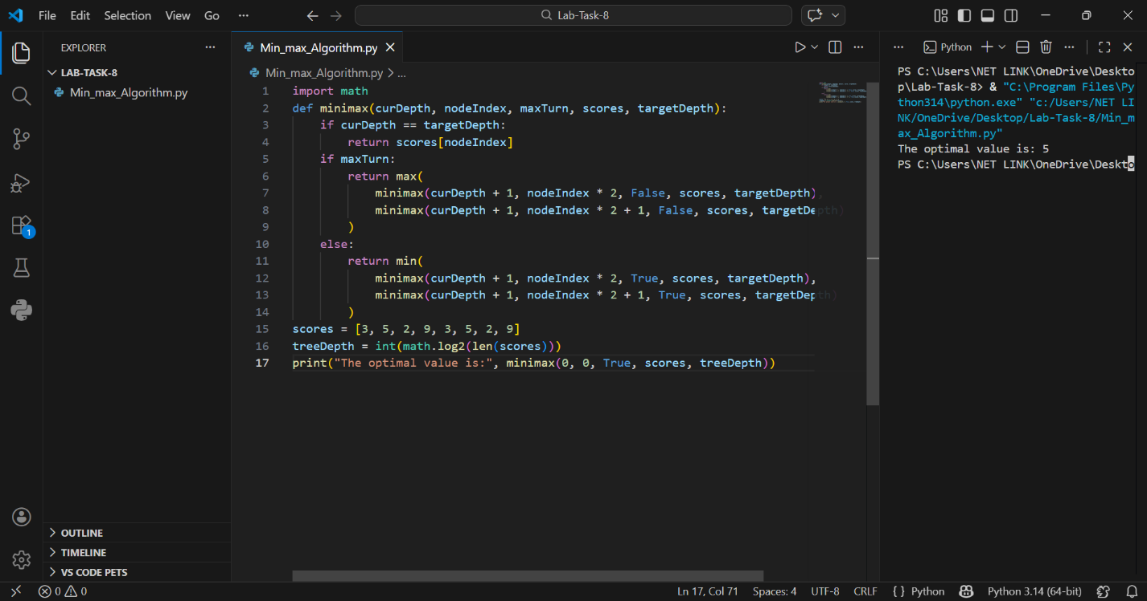

Details:
This program implements the Minimax Algorithm, which is used in game playing and decision-making. It involves two players: one tries to maximize the score, while the other tries to minimize it.
Main Components:
- Function: minimax()
- List: scores(stores leaf node values)
- Variable: maxTurn(decicdes max or min player)
- Library: math

How the Program Works:
1. Start:
The program defines a list of scores representing leaf nodes:
Scores = [3,5,2,9,3,5,2,9]
2. Tree Depth:
The depth of the tree is calculated using:
treeDepth = int(math.log2(len(scores)))
3. Base Case:
When the recursion reaches the last level (leaf nodes), it returns the value from the list.
4. Max Player:
If maxTurn = True, the function selects the minimum value from child nodes.
6. Recursion:
The function keeps calling itself for left and right child nodes until the final result is obtained.

